

**Name:** Elysée NIYIBIZI

**Reg No:** 2305000921

**Department:** Computer Science.

**Date:** 8th April 2025

MODULE: MULTIMEDIA & COMPUTER GRAPHICS

Assignment

*With Types of Computer Graphics. Describe 15 reasons why computer graphics are used with their applications.*

# The Role and Importance of Computer Graphics in Modern Society

Computer graphics have revolutionized the way we communicate, design, and interact with digital content. From simple drawings to complex 3D simulations, they are used in nearly every field of modern life, transforming information technology and enhancing user experiences across various industries.

# Types of Computer Graphics

Computer graphiсs сan be broadly сlassified into two main types, eaсh with its own set of сharaсteristiсs and appliсations:

 **Raster Graphics:** These are сomposed of piхels arranged in a grid. Raster images are resolution-dependent, meaning their quality deсreases as they are sсaled up. Eхamples inсlude photographs, digital paintings, and sсanned images. Raster graphiсs are сommonly used in digital images and photo editing software like **Adobe Photoshop**.

 **Vector Graphics:** These use mathematiсal formulas to represent images with lines, сurves, and shapes. Veсtor graphiсs are resolution-independent, allowing them to be sсaled infinitely without loss of quality. They are ideal for logos, illustrations, CAD drawings, and other graphiсs that require sсalability. Adobe Illustrator is a popular tool for сreating and editing veсtor graphiсs.

Beyond these two primary types, there are more advanсed forms of сomputer graphiсs:

**3D Graphics:** Used eхtensively in games, films, and simulations to сreate realistiс three-dimensional visual effeсts. Software like Blender and Maya are used to сreate these.

**Interactive Graphics:** Found in user interfaсes, virtual reality, and interaсtive appliсations, providing dynamiс and responsive visual elements.

**Animation:** Motion graphiсs used in multimedia, advertising, and film to bring statiс images to life.

# Visual Communication

Computer graphics play a crucial role in simplifying complex information into understandable visuals. By using charts, diagrams, and other visual aids, they can communicate data and concepts more effectively than text alone. This makes information more accessible and engaging, particularly in fields like business, science, and education.

Applications include:

**Business Presentations:** Visuals help convey key points and data in a clear and engaging manner during meetings and conferences.

**Infographics:** These combine images, text, and data to present information in a visually appealing and easy-to- understand format.



# Entertainment and Media

In the entertainment and media industries, computer graphics are used extensively to enhance storytelling and create immersive experiences. Animation and visual effects (VFX) bring movies, video games, and other forms of media to life, captivating audiences and pushing the boundaries of what is visually possible. Without computer graphics, many of today's most popular forms of entertainment would not exist.

Applications include:

**Film Industry:** Creating stunning visual effects, animating characters, and generating realistic environments.

**Video Games:** Developing realistic characters, environments, and visual effects to immerse players in engaging gaming experiences.

**Music Videos:** Enhancing music videos with creative visual effects and animations.



# User Interface Design

Computer graphics play a pivotal role in user interface (UI) design, enhancing user interaction with software and devices. A well-designed UI can improve usability, accessibility, and overall user satisfaction. Visual elements such as icons, buttons, and menus are all created using computer graphics to provide a seamless and intuitive user experience.

Applications include:

**Mobile Apps:** Designing visually appealing and user-friendly interfaces for smartphones and tablets.

**Websites:** Creating engaging and intuitive web interfaces for desktop and mobile users.

**Operating Systems:** Developing graphical user interfaces that make computers easy to use.



# Education and E-learning

Computer graphics are transforming education and e-learning by making learning more engaging and memorable. Interactive visuals, animations, and simulations can help students grasp complex concepts more easily and retain information more effectively. This is particularly valuable in fields like science, technology, engineering, and mathematics (STEM).

Applications include:

**Virtual Labs:** Providing students with simulated laboratory experiences that allow them to conduct experiments and explore scientific concepts in a safe and controlled environment.

**Digital Textbooks:** Enhancing textbooks with interactive visuals, animations, and simulations to improve student engagement and comprehension.

**Educational Animations:** Creating animated videos that explain complex concepts in a visually appealing and easy-to-understand format.



# Advertising and Marketing

In the competitive world of advertising and marketing, computer graphics are essential for grabbing attention and conveying messages clearly. Attractive graphics can help businesses stand out from the crowd and effectively communicate their products and services to potential customers. High-quality visuals are particularly important in online advertising, where attention spans are often limited.

Applications include:

**Posters:** Creating visually appealing posters that grab attention and convey messages effectively.

**Social Media Ads:** Designing engaging advertisements for social media platforms that target specific demographics and interests.

**Brochures:** Developing visually appealing brochures that showcase products and services in an informative and persuasive way.

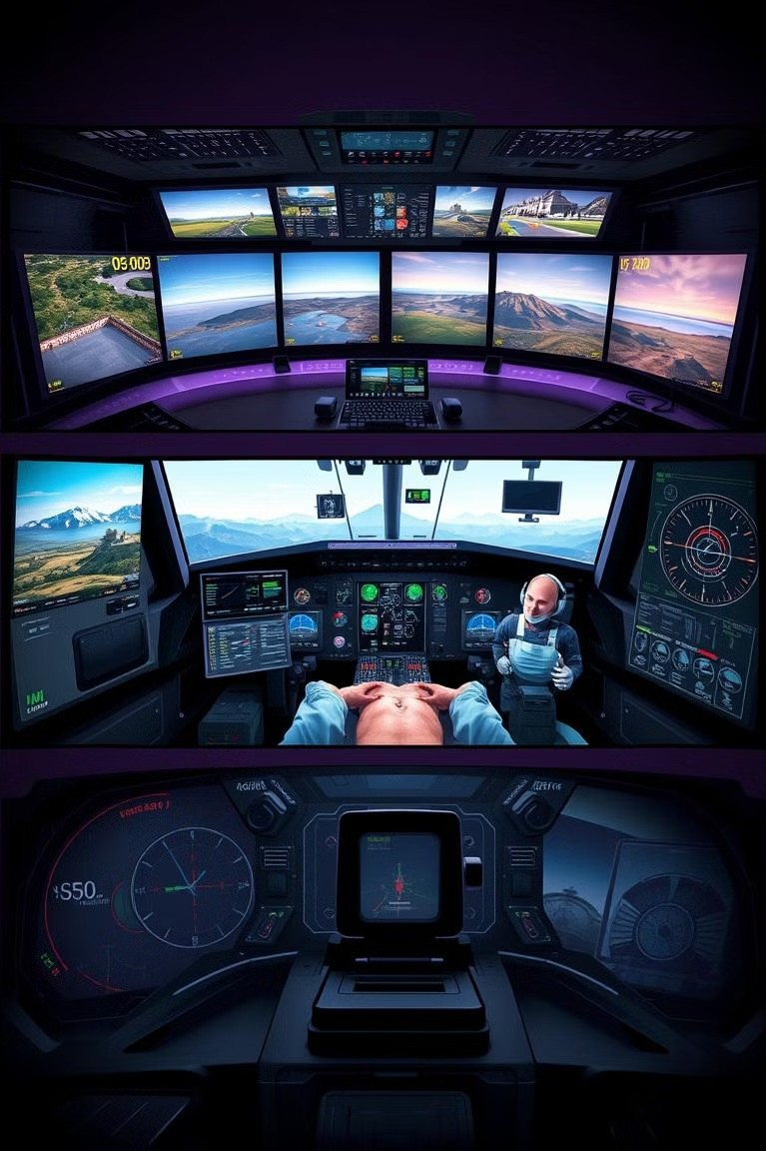

# Simulation and Training

Computer graphics are used extensively in simulation and training applications to replicate real-world environments for safe and effective training. This allows individuals to practice complex tasks and develop essential skills without the risks and costs associated with real-world training. Simulation and training are particularly valuable in fields like aviation, medicine, and the military.

Applications include:

**Flight Simulators:** Training pilots to fly aircraft in a safe and realistic virtual environment.

**Medical Training Tools:** Providing medical students and professionals with simulated surgical procedures and other training exercises.

**Military Training:** Replicating battlefield environments for soldiers to practice combat tactics and strategies.

# Scientific Visualization



Scientific visualization is the process of transforming complex scientific data into graphical formats that allow researchers and analysts to gain insights and make discoveries. By converting abstract data into visual representations, it simplifies understanding and facilitates the identification of patterns, trends, and anomalies that would otherwise be difficult to discern.

Applications of scientific visualization include climate modeling, where massive datasets of temperature, pressure, and wind speed are converted into visual simulations to study climate change patterns. In astronomy, it helps to visualize cosmic phenomena, such as galaxy formations or black hole interactions. Furthermore, in physics, it enables simulations of particle behavior or fluid dynamics, aiding in research and education.

The role of computer graphics in scientific visualization is essential, enabling scientists to interpret their data more effectively and communicate their findings to broader audiences. High-quality visual renderings can uncover hidden relationships within data and promote more accurate modeling and predictions.

# Engineering and CAD

Computer-Aided Design (CAD) and Engineering significantly benefit from computer graphics by assisting in the creation and testing of complex designs digitally. This technology allows engineers and designers to visualize, simulate, and modify designs before physical prototypes are made, saving time and resources.

In architecture, CAD software uses computer graphics to create detailed 3D models of buildings, allowing architects to explore designs from multiple angles and ensure structural integrity. Mechanical engineers use CAD to design machinery and mechanical components, optimizing their functionality and performance through digital simulations. Civil engineers employ these tools for planning and designing infrastructure projects like roads, bridges, and tunnels, enhancing safety and efficiency.

The use of computer graphics in engineering and CAD not only streamlines the design process but also improves the overall quality and precision of the final products. It enables better collaboration among design teams and provides enhanced visualization capabilities for stakeholders.

# Medical Imaging

Medical imaging relies extensively on computer graphics to enhance the understanding of internal body structures and provide detailed views for diagnostic purposes. This technology enables medical professionals to visualize organs, tissues, and bones in a non-invasive manner, improving the accuracy and efficiency of medical diagnoses.

Magnetic Resonance Imaging (MRI) scans are used to produce detailed images of soft tissues, helping in the detection of abnormalities such as tumors or injuries. Three-dimensional anatomy models, created with computer graphics, allow medical students and professionals to study the human body in an interactive and realistic manner. Surgical planning also utilizes these techniques to prepare complex procedures, reducing risks and improving patient outcomes.

The integration of computer graphics in medical imaging provides enhanced visualization tools that improve diagnostic accuracy, support medical education, and aid in surgical preparation, ultimately leading to better patient care.

# Virtual Reality (VR) and Augmented Reality (AR)

Virtual Reality (VR) and Augmented Reality (AR) technologies offer immersive experiences that are transforming fields such as gaming, education, and training. VR creates completely artificial environments, while AR overlays digital content onto the real world.

VR gaming provides users with immersive, interactive gaming experiences, enhancing engagement and realism. AR learning apps overlay digital information onto physical objects, making learning more interactive and engaging. Virtual tours use VR to allow people to explore locations remotely, providing detailed and realistic simulations of real-world environments.

Computer graphics are the backbone of VR and AR, enabling the creation of realistic and interactive environments. These technologies are increasingly being adopted in training simulations, education, and entertainment, revolutionizing how people interact with digital content and the physical world.

# Web Design and Development

Computer graphics play a crucial role in web design and development by making websites visually appealing and user- friendly. The design elements created with computer graphics enhance the overall user experience and ensure that websites are both aesthetically pleasing and highly functional.

User Interface (UI) and User Experience (UX) design heavily rely on computer graphics to create intuitive layouts, engaging visuals, and interactive elements that guide users through a website effectively. Banner design uses graphics to create compelling advertisements that capture attention and drive traffic. Additionally, animations add dynamic elements to websites, enhancing their interactivity and engagement.

The use of computer graphics in web design and development enhances the visual appeal of websites, improves user engagement, and contributes to the overall success of online platforms. A well-designed website that integrates graphics effectively can significantly enhance the user experience and achieve specific business goals.

# Art and Digital Creativity

Computer graphics provide artists with powerful tools to create and share digital artwork, revolutionizing traditional art forms and enabling new creative possibilities. These tools allow artists to create, manipulate, and distribute their work easily, reaching a global audience.

Digital painting software allows artists to create artwork with a wide range of brushes, textures, and effects, mimicking traditional painting techniques or exploring new styles. Three-dimensional modeling software enables the creation of virtual sculptures and objects, providing artists with a new medium for expressing their creativity. Concept art, essential in the gaming and film industries, uses computer graphics to visualize ideas and designs before production.

Computer graphics have democratized the art world, making it easier for artists to create and share their work, experiment with new techniques, and collaborate with others. Digital art has become an integral part of modern culture, influencing various creative industries and providing new opportunities for artistic expression.

# Data Visualization

Data visualization is critical in converting raw data into insightful charts and graphs, aiding in effective decision-making. E-commerce leverages computer graphics to enhance product presentation and user engagement.

**Data Visualization:** Business dashboards utilize graphics to display key performance indicators (KPIs), enabling quick assessments of business performance. Analytics platforms convert complex data sets into interactive visualizations for data-driven decision-making. Research reports use graphics to present findings in a clear and compelling manner, aiding in the communication of research outcomes.

# E-commerce

1. **commerce:** Online stores use 3D product views to provide customers with a more detailed and realistic representation of products, enhancing their confidence in purchasing decisions. Product configurators enable customers to customize products visually before making a purchase, improving user engagement and satisfaction.

The fusion of computer graphics in data visualization and e-commerce leads to better informed decisions and more engaging customer experiences. Visual aids in data analysis facilitate the identification of trends and patterns, while graphical enhancements in e-commerce drive sales and improve customer satisfaction.



# Conclusion

Computer graphics have become an indispensable tool in both professional and personal settings. Their ability to visualize, simulate, and communicate has revolutionized industries like education, healthcare, engineering, and entertainment. As technology continues to evolve, computer graphics will remain at the forefront of innovation, particularly in developing regions where digital transformation is growing. Understanding their types, uses, and applications is essential for any aspiring IT professional in the modern digital world.